## Mengzhou Yao

## 09/01/2020

## IT FDN 110 A

## Assignment09

## <https://github.com/myao3/IntroToProg-Python-Mod09>

**Assignment 09**

**Introduction**

In this assignment 09, the script will display a list of menu to the user: Show current data; Add a new item; Save Data to File; Exit Program by importing script files.

**Procedure**

Creating Script

I import Dataclasses script file and use class employee function as emp, import processingclasses script file and use fileprocessor function as Fp, import IOClasses script file and use EmployeeIO as Eio.

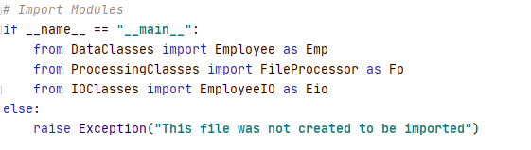

*Figure 1: the screenshot of import modules in the PyCharm program*

I add object 1 and Object 2 as #, first name, last name and list them to lstTable; I save the lstTable to EmployeeData.txt; clear the lstTable; read the data from EmployeeData.txt

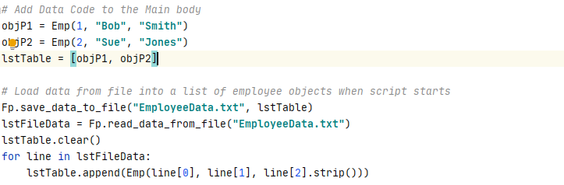

*Figure 2: the screenshot of add data and load data in the PyCharm program*

I display the list of menu and input the menu option for user by importing IOClasses script file and use EmployeeIO as Eio; I display the current list to the user when the I choose the menu option 1; I input employee #, first name and last and append to the lstTable when the I choose the menu option 2; I save the current list (lstTable) to EmployeeData.txt by importing processingclasses script file and use fileprocessor function as Fp when I choose the menu option 3; I exit the program when I choose menu option 4. When I choose number other than 1 or 2 or 3 or 4, I receive the error message ('Oops! That was no valid number. Try again...').

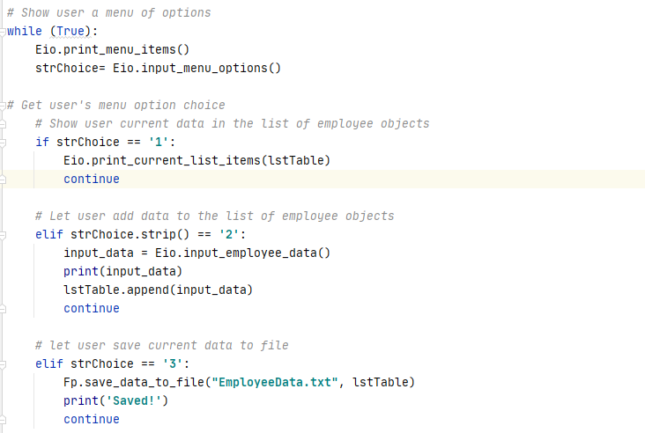

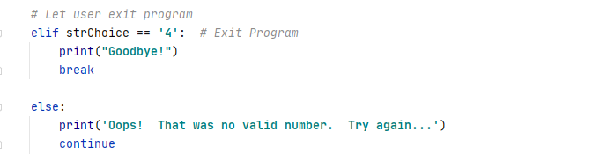

*Figure 3: the screenshot of the main body in the PyCharm program*

Saving the script

I create a folder in C:\_PythonClass called “Assignment09” and save my script as “Assigment09”.

Running the script

I open PyCharm in search windows and open the “Assignment09” to run module, I choose “1” to display the current data. I choose “2” to add new product name and its price. I choose “3” to sav data to file. I choose “4” to exit program.

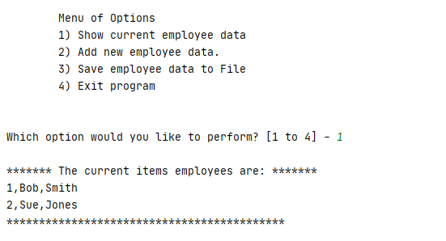

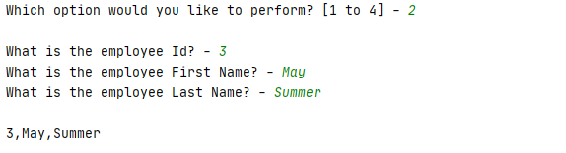

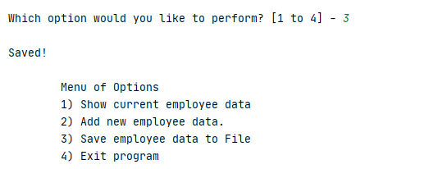

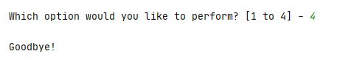

*Figure 4: the screenshot of running the script in the PyCharm program*

Verifying data in the txt.file

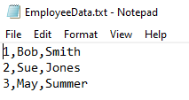

*Figure 5: the screenshot of verifying data in the txt file*

**Summary**

Using the module 09 video, notes, textbook, and supplemental video, I was able to import script files and add code in the Assignment 09 by letting user to display the data, enter the data, save the data and exit the program.